5th Grade Math Parent Guide
 | 1st Grading Period | 2nd Grading Period | 3rd Grading Period | 4th Grading Period
Units/TEKS  Process Standards 5.1ABCDEFG through every unit  TEKS | Unit 6: Place Value with Decimals  5.2AB  Unit 1: Place Value and Operations  5.3AB  Unit 7: Multiplication and Division-Whole Numbers  5.3ABC, 5.4AB  Order of Operations and Multi-Step Problems:  5.4BEF | Unit 6: Addition, Subtraction, Multiplication and Division with Decimals  5.2C, 5.3ADEFGK  Perimeter, Area, and Volume  5.4GH, 5.6AB | Unit 5: 2D shapes  5.5A  Unit 4: Fractions  5.3AHIJKL; 5.4A  Coordinate Planes  5.8ABC, 5.4CD | Measurement  5.7A  Unit 9: Data and Graphs  5.9ABC  Personal Financial Literacy  5.10ABCDEF
Topic Focus | Unit 6: This unit focuses on understanding the meaning of decimal fractions and comparing decimals.  Unit 1: This unit develops ideas about the meaning of operations with whole numbers, the development of computational fluency, the structure of place value, and the base-ten number system, and generalizations about numbers and operations.  Unit 7: The mathematical focus in this unit is reasoning about equivalent expressions in multiplication and division, representing the meaning of multiplication and division, solving multiplication problems with 2-digit and 3-digit numbers, and solving problems with two-digit divisors.  Order of Operations: This unit focuses on the rules of the order of operations and how to solve multi-step word problems. | Unit 6: This unit focuses on understanding the meaning of decimal fractions, comparing decimals, and adding, subtracting, multiplying, and dividing decimals.  Perimeter, Area, and Volume: This unit reviews how to find perimeter and area and solve word problems about perimeter and area. Volume is introduced in this unit and how to find the volume of a rectangular prism. | Unit 5: This unit develops ideas about the attributes of 2-D shapes and how they determine the classification of the shapes. It also delves into area, perimeter, and volume.  Unit 4: This unit develops ideas on the understanding the meaning of fractions, comparing fractions, and adding and subtracting fractions.  Coordinate Planes: This unit focuses on the key attributes of a coordinate plane, the process for graphing ordered pairs of numbers, and generating additive and multiplicative number patterns. | Measurement: This unit focuses on measurement conversions within customary and metric systems.  Unit 9: This unit focuses on representing, describing, summarizing, and comparing data.  Personal Financial Literacy: This unit focuses on taxes, income, financial records, and balancing a budget.
Suggestions for Parental Involvement/Support | Multiplication  To prepare for the standard U.S. algorithm, the partial product strategy is used by many fifth graders. This strategy emphasizes place value and multiples of ten as well as builds an understanding of how the distributive property works.  Partial Products  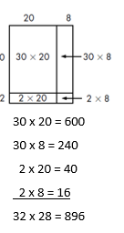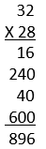  Division with and without Remainders  Students will use what they know about multiplication to help them solve division problems. This connection can be seen when division and multiplication situations are presented simultaneously in story contexts. The story contexts help students make sense of the problem and interpret what the remainder really means in the context of the story.  There were 384 seats in the movie theater. Each row has 16 seats. How many rows are in the movie theater?  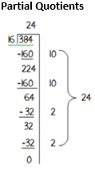  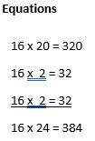  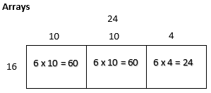 | Multiplying Decimals  0.42 X 4  Repeated addition or 4 groups of .42  0.42 + 0.42 + 0.42 + 0.42  Distributive Property  (0.42 X 2) + (0.42 X 2)  0.84 + 0.84  Estimate Reasonableness  0.42 is close to .5 or half. Half of 4 is 2, so I know my answer has to be less than 2.  Array Model  Array Model  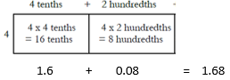  Array Model Combined with Groups of  Think about the groups of strategy: 4 tenths of 8 tenths. Shade in 4 tenths on one side and 8 tenths on the other. The product is the part that is double-shaded because it is a group of a group. 0.8 x 0.4 -0.32  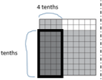  Dividing Decimals  1.2 ÷ 0.3  Groups of or Sharing into Groups  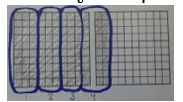  Shade in 1.2 on a ten by ten grid. Then create as many groups of 3 tenths as possible. The answer is 4 because you could make 4 groups of 0.3. | Multiplying Fractions  $\frac{1}{4}$ x 12  Repeated Addition combined with the Commutative Property  $\frac{1}{4}$ of 12 is the same as 12 groups of $\frac{1}{4}$  $\frac{1}{4}$ + $\frac{1}{4}$ + $\frac{1}{4}$ + $\frac{1}{4}$ + $\frac{1}{4}$ + $\frac{1}{4}$ + $\frac{1}{4}$ + $\frac{1}{4}$ + $\frac{1}{4}$ + $\frac{1}{4}$ + $\frac{1}{4}$ + $\frac{1}{4}$  1 whole + 1 whole + 1 whole = 3  Create a Model or Tape Diagram  3  3  3  3  The length of the tape is 12. Since we need one fourth, I need to make four equal groups. Since each piece shows the same amount, we can divide 12 by 4 and that’s 3. So $\frac{1}{4}$ of 12 is 3.  Array Model  Draw an array of 12 circles. We need one fourth of those circles in a group, so divide the circles into 4 equal groups. Each group is one fourth of the total. So one fourth of 12 is 3  Estimate Reasonableness  $\frac{1}{4}$ is less than $\frac{1}{2}$ . I know that half of 12 is 6. So, I know my answer has to be less than 6.  Dividing Fractions  2 ÷ $\frac{1}{3}$  Groups of or Sharing into Groups  How many groups of $\frac{1}{3}$ are in 2?  $$\frac{1}{3}$$  $$\frac{1}{3}$$  $$\frac{1}{3}$$  $$\frac{1}{3}$$  $$\frac{1}{3}$$  $$\frac{1}{3}$$  There are 6 groups of $\frac{1}{3}$ in 2 wholes.  Estimate Reasonableness  3 groups of $\frac{1}{3}$ in 1 whole  6 groups of $\frac{1}{3}$ in 2 wholes  $\frac{1}{3}$ ÷ 2  Create a Model or Diagram  Draw a model of one third. Divide it into 2 equal groups. How do we describe these pieces? They are $\frac{1}{6}$ of the whole.  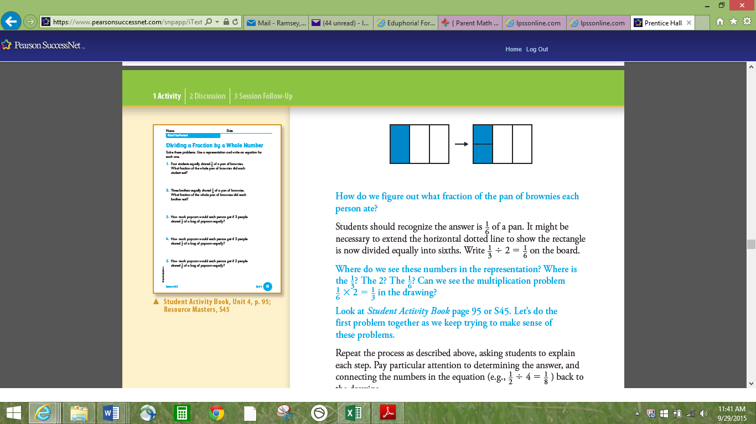  Geometry Vocabulary  Polygons-Any closed 2D shape with 3 or more straight sides  Quadrilateral-Any 4-sided polygon  Parallelogram-A quadrilateral that has two pairs of sides that are equal (congruent) and parallel.  Trapezoid-A quadrilateral that as exactly one pair of parallel sides.  Rectangle-A quadrilateral with two pairs of congruent, parallel sides and four right angles. A rectangle can also be called a parallelogram.  Square-A quadrilateral with congruent sides and four right angles. A square can also be called a parallelogram, rhombus, and rectangle.  Rhombus-A quadrilateral with four congruent sides and opposite sides are parallel.  Triangle-Any 3 sided polygon.  Equilateral triangle-all sides and angles  are congruent.  Isosceles triangle-2 congruent sides and  angles  Scalene triangle-no congruent sides or  angles  Obtuse triangle-largest angle is greater  than 90 degrees  Acute triangle- all angles are less than  90 degrees  Right triangle-largest angles is a 90  degree angle  Coordinate Planes  Play Battleship. This is a great way to learn how to plot and name points on a coordinate plane. | Stem and Leaf Plots  The stem and leaf plot is a method of organizing data in order of place value. The ones digit and the tens digit (or additional place values) of each data item are separated as leaves and stems.  Sam and his friends did the Long Jump. Here are there results in meters:  2.3, 2.5, 2.5, 2.7, 2.8, 3.2, 3.6, 3.6, 4.5, 5.0  Here is the stem and leaf plot he made to represent his data:  In this graph, the stem represents the whole numbers in each piece of data. The leaf represents the decimal in each piece of data.  2.3 = 2 is the stem and .3 is the leaf  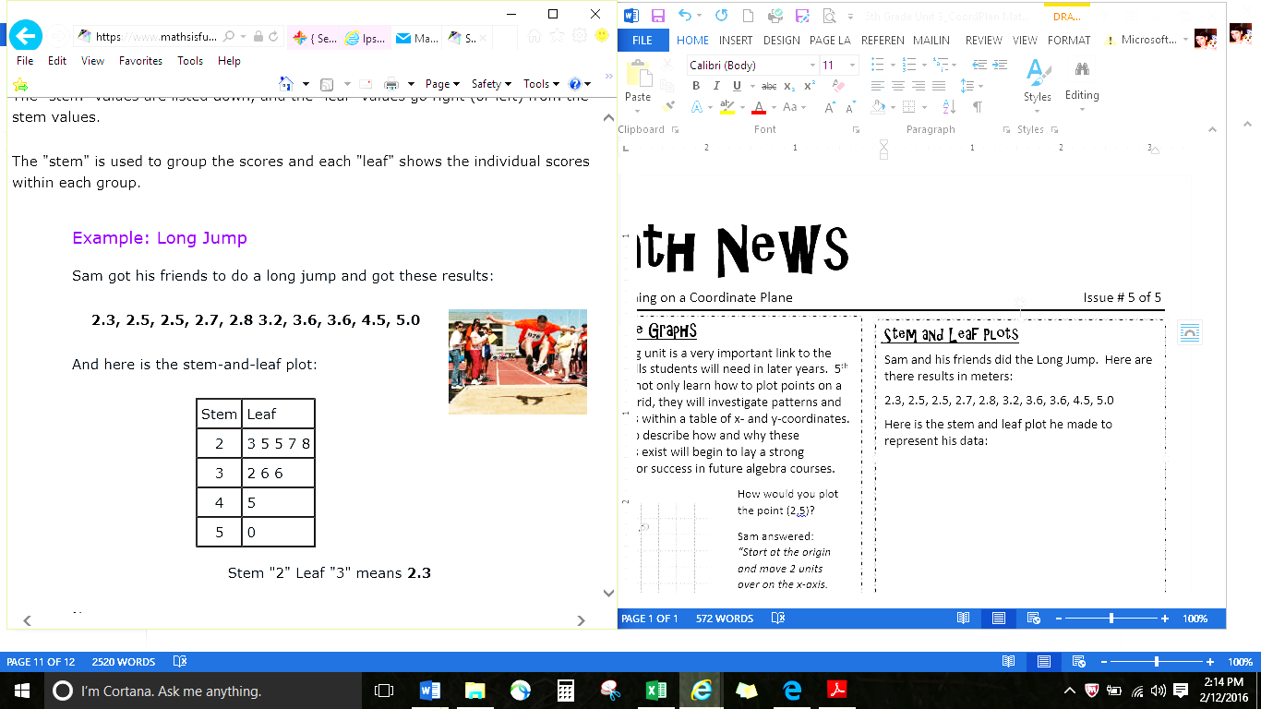  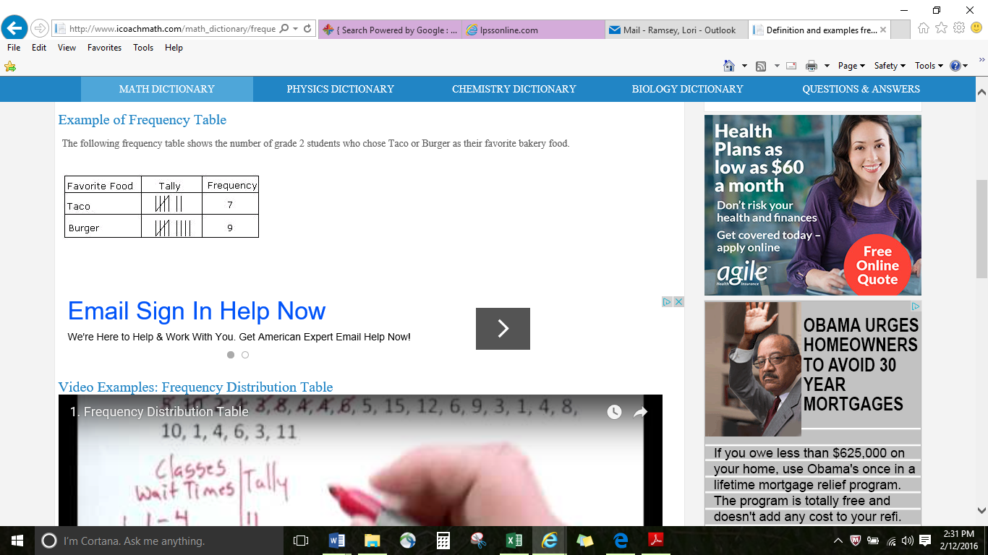  Frequency Table  A table that lists items and uses tally marks to record and show the number of times they occur.  Dot Plot  A set of data is represented by using dots over a number line. The number of dots over the number line tells the number of times that data occurred in the set.  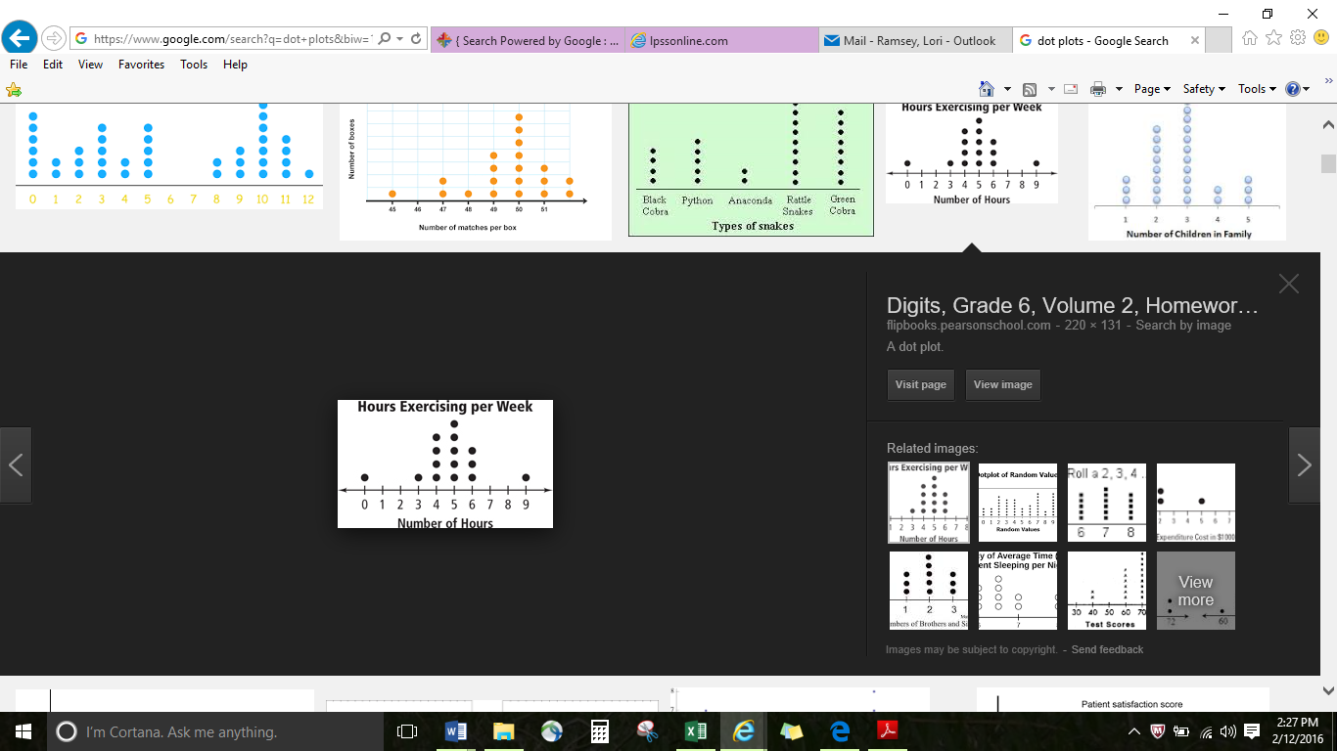
General Resources | Math 4 Texas: https://www.math4texas.org/  Graham Fletcher Progression Videos: https://gfletchy.com/progression-videos/  Interactive Math Glossary: https://www.texasgateway.org/resource/interactive-math-glossary  ST Math: sso.ems-isd.net  Khan Academy: https://www.khanacademy.org/math

